**JAVA SWINGS BASED- Animal Species Database- SQL CONNECTIVITY USING JDBC**

***DBMS Project Report***

***Submitted in partial fulfilment of the***

***Requirements for the award of the Degree of***

**BACHELOR OF ENGINEERING**

IN

**INFORMATION TECHNOLOGY**

BY

*MOHD ADEEB JALALUDDIN (1602-20-737-301)*

Under the guidance of



Department of Information Technology

Vasavi College of Engineering (Autonomous)

(Affiliated to Osmania University)

Ibrahimbagh, Hyderabad-31 2020

**DECLARATION BY THE CANDIDATE**

I MOHD ADEEB JALALUDDIN bearing hall ticket numbers, **1602-20-737-301** hereby declare that the project report entitled **“Animal Species Database”** Department of Information Technology, Vasavi College of Engineering, Hyderabad, is submitted in partial fulfilment of the requirement for the award of the degree of Bachelor of Engineering in Information Technology

This is a record of bonafide work carried out by me and the results embodied in this project report have not been submitted to any other university or institute for the award of any other degree or diploma.

**MOHD ADEEB JALALUDDIN**

**1602-20-737-301**

**(Faculty In-Charge) (Head,Dept of IT)**

***Abstract :***

The main objective of this project is to find which animal species the user is looking for and group the features and display them the user gives the features and what to identify for which animal this features belongs to. This project give us the animal name along with its features when the user specifies any of the features .

•The animal species database request to table the animal table, the features table and the “has” table which is formed with the relation of animal and features table.

•The attributes of animal table are aid (animal id) of Domain type number which is the primary key of the animal table and aname(animal name) of domain type varchar2 and atype (animal type) of domain type varchar2 .

•Attributes of feature tables are fname(feature name) of type varchar2 and fname(feature name) off type varchar2 and fdesc(feature description) of type varchar2.

* Attributes of “has” table hid which is a primary key of the “has ”

Table of Domain type number , aname of Domain type varchar2 ,fname of domain type varchar2 and fdesc of domain type varchar2 .These tables receive the data from the animal table and features table respectively.

***AIM AND PRIORITY OF THE PROJECT :***

To create a Java GUI based management system for projects made by students in a particular college. All the values are to be updated and handled in the database using JDBC connectivity .

**ARCHITECTURE AND TECHNOLOGY USED :**

VS Code , Oracle 11g Database, Java SE version 8, MYSQL Developer.MYSQL developer is an Oracle Database utility, commonly used by users, administrators and programmers.

The interface of SQL Developer is used for creating the database. DDL and DML commands are implemented for operations being executed. The details of “animal “,”features” and “has” and their values are stored in the form of tables in the database.

VSCode is an integrated development environment (IDE) used in computer programming. It contains a base workspace and an extensible plug-in system for customizing the environment. VSCode its primary use is for developing java applications, but it may also be used to develop applications in other programming languages via plug-ins, including Erlang, JavaScript etc.

The front-end application code is written in “Java” using VSCode. The portal for front end application is designed through VSCode, runs and has the capacity to connect with the database which has data inserted using MYSQL.

**Java Swing** tutorial is a part of Java Foundation Classes (JFC) that is used to create window-based applications. It is built on the top of AWT (Abstract Windowing Toolkit) API and entirely written in java. Unlike AWT, Java Swing provides platform-independent and lightweight components. The javax.swing package provides classes for java swing API such as JButton, JTextField, JTextArea, JRadioButton, JCheckbox, JMenu, JColorChooser etc.

**Java-SQL Connectivity using JDBC :**

Java Database Connectivity (JDBC) is an application programming interface (API) for the programming language Java, which defines how a client may access a database. It is a Java-based data access technology used for Java database connectivity. It is part of the Java Standard Edition platform, from Oracle Corporation. It provides methods to query and update data in a database and is oriented towards relational databases.

**DESIGN :**

* ***Entity Relationship Diagram :***

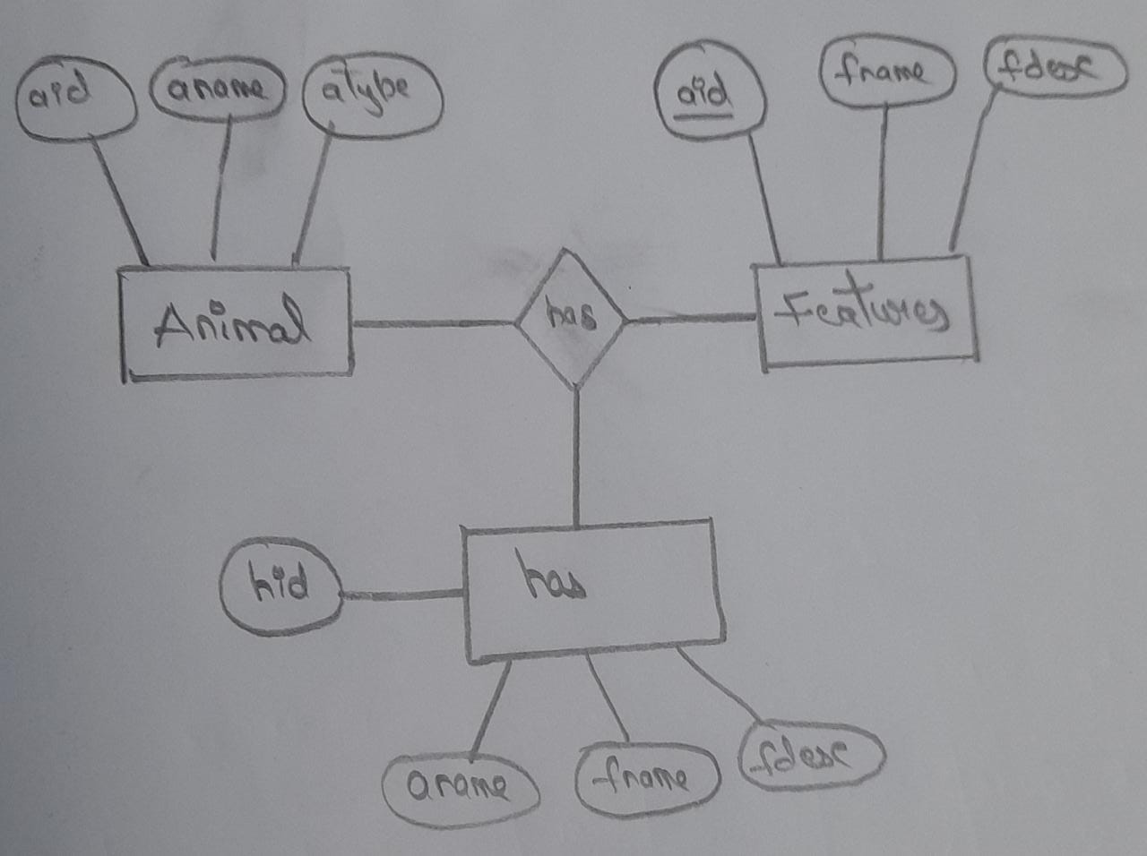

* ***Database design :***

1. ***DDL OPERATIONS AND ENFORCING CONSTRAINTS :***

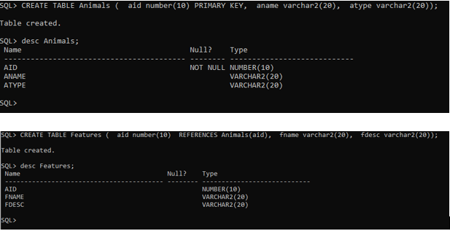

1. ***DML OPERATIONS :***

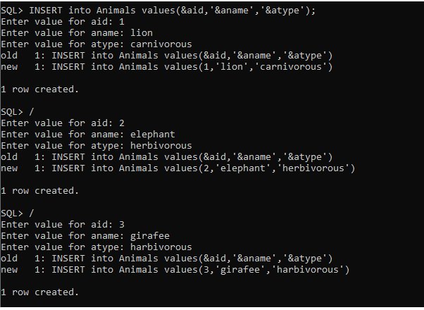

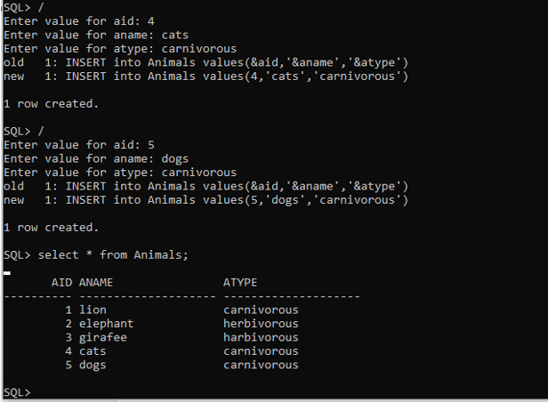

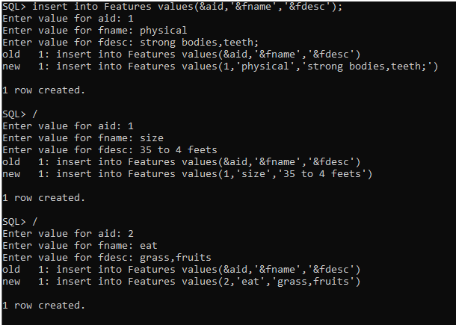

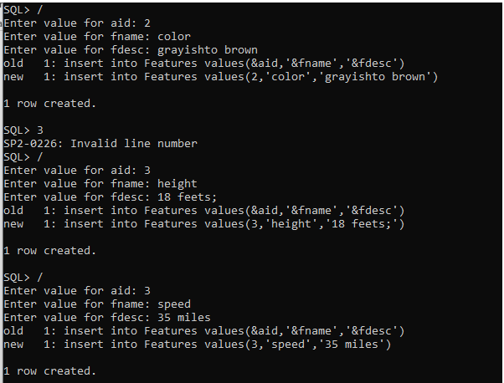

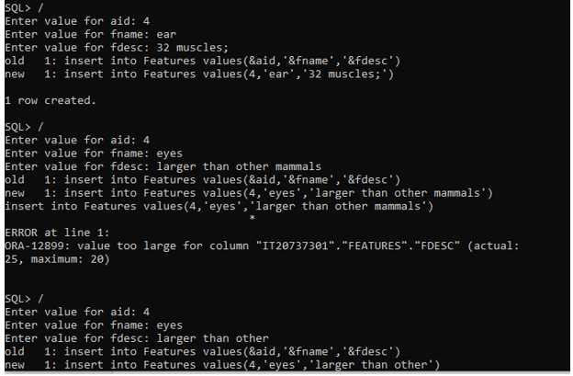

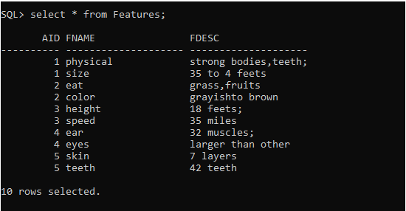

* ***IMPLEMENTATION :***

**Welcome page :**

import java.awt.*;

import javax.swing.*;

import java.awt.event.*;

//import java.net.URI;

//import javax.swing.plaf.ColorUIResource;

 class Firstpage extends JFrame implements ActionListener{

    private Container c;

    private JLabel title;

    private JButton sub;

    public  Firstpage() {

        setTitle("Animal DataBase");

        setBounds(500,190,900,600);

        setDefaultCloseOperation(EXIT_ON_CLOSE);

        setLocationRelativeTo(null);

        Color r1 = new Color(142, 183, 230);

        c = getContentPane();

        c.setBackground(r1);

        c.setLayout(null);

         title = new JLabel("Welcome to Animal DataBase");

         title.setFont(new Font("Arial",Font.BOLD,24));

         title.setSize(500,30);

         title.setLocation(300, 100);

         title.setForeground(Color.DARK_GRAY);

         c.add(title);

         sub = new JButton("Click to enter");

         sub.setFont(new Font("Arial",Font.PLAIN,20));

         sub.setSize(200,50);

         sub.setLocation(330,250);

         sub.setForeground(Color.DARK_GRAY);

         sub.addActionListener(this);

         c.add(sub);

    }

    public void actionPerformed(ActionEvent e)

    {

        try{

            Secondpage s = new Secondpage();

            s.setVisible(true);

            dispose();

        }

        catch(Exception exception)

        {

            System.out.println("Exception");

        }

    }

    public static void main(String[] args) {

        Firstpage f = new Firstpage();

        f.setVisible(true);

    }

}

**Display page :**

import java.awt.*;

import javax.swing.*;

import java.awt.event.*;

import java.sql.*;

public class Secondpage extends JFrame implements ActionListener

{

    Connection con;

    Statement stmt;

    private TextField tf,t1;

    private Container c;

    private JButton b1,b2,b3,b4,b5;

    private JLabel l,l2,l3;

    public JComboBox<String> combo1;

    public Secondpage()

    {

        connect();

        c = getContentPane();

        setDefaultCloseOperation(EXIT_ON_CLOSE);

        setBounds(500,190,900,600);

        setLocationRelativeTo(null);

        l = new JLabel("Animal Name :");

        l.setBounds(0,50,170,20);

        l.setFont(new Font("Serif",Font.BOLD,18));

        l.setForeground(Color.black);

        tf=new TextField();

        tf.setEditable(false);

        tf.setBounds(140,50,170,20);

        l2=new JLabel("Features Des.:");

        l2.setBounds(0,100,170,20);

        l2.setFont(new Font("Serif",Font.BOLD,20));

        t1=new TextField();

        t1.setEditable(false);

        t1.setBounds(140,105,250,20);

        l3=new JLabel("Features names :");

        l3.setBounds(0,160,220,20);

        l3.setFont(new Font("Serif",Font.BOLD,20));

        String features[]={"physical","eat","height","ear","skin"};

        combo1 = new JComboBox<>(features);

        combo1.setEditable(true);

        combo1.setBounds(150,160,170,20);

        b1=new JButton("Display");

        b1.setBounds(200,250,100,20);

        b1.addActionListener(this);

        b2=new JButton("Insertion page");

        b2.setBounds(550,100,130,20);

        b2.addActionListener(this);

        b3=new JButton("Updation page");

        b3.setBounds(550,130,130,20);

        b3.addActionListener(this);

        b4=new JButton("Deletion page");

        b4.setBounds(550,160,130,20);

        b4.addActionListener(this);

        b5 = new JButton("Go Back");

        b5.setSize(130,20);

        b5.setLocation(550,190);

        b5.addActionListener(this);

        Color r1 = new Color(142, 183, 230);

        c.add(b1); c.add(l3);

        c.add(tf); c.add(t1);

        c.add(l); c.add(combo1);

        c.add(l2);

        c.add(b2);

        c.add(b3); c.add(b4);

        c.add(b5);

        c.setBackground(r1);

        c.setSize(1000,1000);

        c.setLayout(null);

        c.setVisible(true);

        setTitle("Animal Database");

    }

    public void  connect()

    {

        try{

            //Class.forName("com.mysql.jdbc.Driver");

            con = DriverManager.getConnection("jdbc:mysql://localhost:3306/animaldb","root","vasavi" );

            stmt  = con.createStatement(ResultSet.TYPE_SCROLL_INSENSITIVE,ResultSet.CONCUR_UPDATABLE);

        }

        catch(SQLException e)

        {

            System.out.println("Exception2");

        }

    }

    public void actionPerformed(ActionEvent e)

    {

        try{

                if(e.getSource() == b5)

                {

                    Firstpage f = new Firstpage();

                    f.setVisible(true);

                    dispose();

                }

                if(e.getSource() == b2)

                {

                    Insertpage i = new Insertpage();

                    i.setVisible(true);

                    dispose();

                }

                if(e.getSource() == b4)

                {

                    Deletepage d = new Deletepage();

                    d.setVisible(true);

                    dispose();

                }

                if(e.getSource() == b3)

                {

                    Updatepage u = new Updatepage();

                    u.setVisible(true);

                    dispose();

                }

                if(e.getSource() == b1)

               try{

                        //String q1 = combo1.getSelectedItem().toString();

                        String sql2 ="SELECT hid FROM has where fname='"+combo1.getSelectedItem().toString()+"'";

                        ResultSet rs1 = stmt.executeQuery(sql2);

                        String jml="";

                        while(rs1.next())

                            jml = rs1.getString(1);

                        String sql1 ="SELECT  aname FROM has where hid="+jml;

                        ResultSet rs = stmt.executeQuery(sql1);

                        if(rs.next())

                        {

                            tf.setText(rs.getString(1));

                        }

                    }

                        catch(Exception expe)

                        {

                            System.out.println(expe);

                        }

                            try{

                                //String q1 = combo1.getSelectedItem().toString();

                                String sql3 ="SELECT hid FROM has where fname='"+combo1.getSelectedItem().toString()+"'";

                                ResultSet rs2 = stmt.executeQuery(sql3);

                                String jml1="";

                                while(rs2.next())

                                    jml1 = rs2.getString(1);

                                String sql4 ="SELECT  fdes FROM has where hid="+jml1;

                                ResultSet rs3 = stmt.executeQuery(sql4);

                                if(rs3.next())

                                {

                                    t1.setText(rs3.getString(1));

                                }

                            }

                            catch(Exception expe)

                            {

                                System.out.println(expe);

                            }

                    }

                }

        catch(Exception exception)

        {

            System.out.println("Exception");

        }

    }

    public static void main(String args[])

    {

        Secondpage s = new Secondpage();

        s.setVisible(true);

    }

}

**Insertion page :**

import java.awt.*;

import javax.swing.*;

import java.awt.event.*;

import java.sql.*;

class Insertpage extends JFrame implements ActionListener{

    private Container c;

    private JButton b1,b2;

    private JTextField t1,t2,t3,t4,t5;

    private JLabel l1,l2,l3,l4,l5,l6;

    JTextArea resultText ;

    Statement st;

    Connection con;

    //Secondpage s = new Secondpage();

            /*s.combo1.addItem(t4.getText());

            s.setVisible(true);*/

    public Insertpage()

    {

        connect();

        setTitle("Animal DataBase");

        setBounds(500,500,900,600);

        setDefaultCloseOperation(EXIT_ON_CLOSE);

        setLocationRelativeTo(null);

        Color r1 = new Color(142, 183, 230);

        c = getContentPane();

        c.setBackground(r1);

        c.setLayout(null);

         l1 = new JLabel("Animal id :");

         l1.setFont(new Font("Serif",Font.BOLD,18));

         l1.setSize(500,30);

         l1.setLocation(0, 70);

         l1.setForeground(Color.DARK_GRAY);

         c.add(l1);

         t1 = new JTextField();

         t1.setFont(new Font("Serif",Font.BOLD,18));

         t1.setSize(200,30);

         t1.setLocation(170, 70);

         t1.setForeground(Color.DARK_GRAY);

         c.add(t1);

         l2 = new JLabel("Animal name :");

         l2.setFont(new Font("Serif",Font.BOLD,18));

         l2.setSize(500,30);

         l2.setLocation(0, 110);

         l2.setForeground(Color.DARK_GRAY);

         c.add(l2);

         t2 = new JTextField();

         t2.setFont(new Font("Serif",Font.BOLD,18));

         t2.setSize(200,30);

         t2.setLocation(170, 110);

         t2.setForeground(Color.DARK_GRAY);

         c.add(t2);

         l3 = new JLabel("Animal Type :");

         l3.setFont(new Font("Serif",Font.BOLD,18));

         l3.setSize(500,30);

         l3.setLocation(0, 150);

         l3.setForeground(Color.DARK_GRAY);

         c.add(l3);

         t3 = new JTextField();

         t3.setFont(new Font("Serif",Font.BOLD,18));

         t3.setSize(200,30);

         t3.setLocation(170, 150);

         t3.setForeground(Color.DARK_GRAY);

         c.add(t3);

         l4 = new JLabel("Feature name :");

         l4.setFont(new Font("Serif",Font.BOLD,18));

         l4.setSize(500,30);

         l4.setLocation(0, 190);

         l4.setForeground(Color.DARK_GRAY);

         c.add(l4);

         t4 = new JTextField();

         t4.setFont(new Font("Serif",Font.BOLD,18));

         t4.setSize(200,30);

         t4.setLocation(170, 190);

         t4.setForeground(Color.DARK_GRAY);

         c.add(t4);

         l5 = new JLabel("Feature Description :");

         l5.setFont(new Font("Serif",Font.BOLD,18));

         l5.setSize(500,30);

         l5.setLocation(0, 230);

         l5.setForeground(Color.DARK_GRAY);

         c.add(l5);

         t5 = new JTextField();

         t5.setFont(new Font("Serif",Font.BOLD,18));

         t5.setSize(200,30);

         t5.setLocation(170, 230);

         t5.setForeground(Color.DARK_GRAY);

         c.add(t5);

         b1 = new JButton("Insert into table");

         b1.setSize(200,20);

         b1.setLocation(50,300);

         b1.setForeground(Color.DARK_GRAY);

         b1.addActionListener(this);

         c.add(b1);

         b2 = new JButton("Go Back");

         b2.setSize(200,20);

         b2.setLocation(300,300);

         b2.setForeground(Color.DARK_GRAY);

         b2.addActionListener(this);

         c.add(b2);

         l6 = new JLabel("Insertion page:");

         l6.setFont(new Font("Serif",Font.ITALIC,25));

         l6.setSize(500,30);

         l6.setLocation(250, 0);

         l6.setForeground(Color.DARK_GRAY);

         c.add(l6);

         resultText = new JTextArea();

         resultText.setFont(new Font("Serif",Font.ITALIC,25));

         resultText.setSize(550,30);

         resultText.setLocation(200, 350);

         resultText.setForeground(Color.DARK_GRAY);

         c.add(resultText);

    }

    public void  connect()

    {

        try{

            //Class.forName("com.mysql.jdbc.Driver");

            con = DriverManager.getConnection("jdbc:mysql://localhost:3306/animaldb","root","vasavi" );

            st  = con.createStatement(ResultSet.TYPE_SCROLL_INSENSITIVE,ResultSet.CONCUR_UPDATABLE);

        }

        catch(SQLException e)

        {

            System.out.println("Exception2");

        }

    }

    public void actionPerformed(ActionEvent e)

    {

        try{

            if(e.getSource() == b2){

                Secondpage s = new Secondpage();

                s.setVisible(true);

                dispose();

            }

            if(e.getSource() == b1){

                try{

                    int jml = Integer.parseInt(t1.getText());

                    String q1 = t2.getText();

                    String q2 = t3.getText();

                    String q3 = t4.getText();

                    String q4 = t5.getText();

                    String sql = "Insert into Animals values(' "+jml + "','" + q1 + "','" + q2 +"')";

                    st.executeUpdate(sql);

                    String sql1 =  "INSERT INTO Features VALUES(' "+jml + "','" + q3 + "','" + q4 +"')";

                    st.executeUpdate(sql1);

                    String sql2 =  "INSERT INTO has VALUES(' "+jml + "','" + q1 + "','" + q3 +"','" + q4 +"')";

                    st.executeUpdate(sql2);

                    t1.setText("");

                    t2.setText("");

                    t3.setText("");

                    t4.setText("");

                    t5.setText("");

                    resultText.setText("Row Inserted Successfully");

                    Secondpage s = new Secondpage();

                    s.combo1.addItem(q3);

                    s.setVisible(false);

                    con.close();

                    st.close();

                }

                catch(SQLException exp)

                {

                    System.out.println("Exception1");

                }

            }

        }

        catch(Exception exception)

        {

            System.out.println("Exception");

        }

    }

    public static void main(String args[]) throws Exception

    {

        try{

            Insertpage i = new Insertpage();

            i.setVisible(true);

        }

        catch(Exception e)

        {

            System.out.println("Exception 3");

        }

    }

}

**Deletion page :**

import java.awt.*;

import javax.swing.*;

import java.awt.event.*;

import java.sql.*;

class Deletepage extends JFrame implements ActionListener

{

    private Container c;

    private JLabel l1;//l2;

    private JTextField t1;

    JTextArea resultText ;

   // private JComboBox combo1;

    private JButton b1,b2;

    Connection con;

    Statement stmt;

    public  Deletepage()

    {

        connect();

        setTitle("Animal DataBase");

        setBounds(500,190,900,600);

        setDefaultCloseOperation(EXIT_ON_CLOSE);

        setLocationRelativeTo(null);

        Color r1 = new Color(142, 183, 230);

        c = getContentPane();

        c.setBackground(r1);

        c.setLayout(null);

         l1 = new JLabel("Animal id :");

         l1.setFont(new Font("Serif",Font.BOLD,18));

         l1.setSize(500,30);

         l1.setLocation(0, 70);

         l1.setForeground(Color.DARK_GRAY);

         c.add(l1);

         t1 = new JTextField();

         t1.setFont(new Font("Serif",Font.BOLD,18));

         t1.setSize(200,30);

         t1.setLocation(130, 70);

         t1.setForeground(Color.DARK_GRAY);

         c.add(t1);

        /* l2 = new JLabel("Feature name :");

         l2.setFont(new Font("Serif",Font.BOLD,18));

         l2.setSize(500,30);

         l2.setLocation(0, 110);

         l2.setForeground(Color.DARK_GRAY);

         c.add(l2);*/

        /*combo1 = new JComboBox();

        combo1.addItem("physical");

        combo1.addItem("size");

        combo1.addItem("eat");

        combo1.addItem("color");

        combo1.addItem("height");

        combo1.addItem("speed");

        combo1.addItem("ear");

        combo1.addItem("eyes");

        combo1.addItem("skin");

        combo1.addItem("teeth");

        combo1.setEditable(false);

        combo1.setSize(200,30);

        combo1.setLocation(130, 110);

        c.add(combo1);*/

          b1 = new JButton("Delete  From table");

         b1.setSize(200,20);

         b1.setLocation(50,300);

         b1.setForeground(Color.DARK_GRAY);

         b1.addActionListener(this);

         c.add(b1);

          b2 = new JButton("Go Back");

         b2.setSize(200,20);

         b2.setLocation(300,300);

         b2.setForeground(Color.DARK_GRAY);

         b2.addActionListener(this);

         c.add(b2);

         JLabel l6 = new JLabel("Deletion page:");

         l6.setFont(new Font("Serif",Font.ITALIC,25));

         l6.setSize(500,30);

         l6.setLocation(250, 0);

         l6.setForeground(Color.DARK_GRAY);

         c.add(l6);

         resultText = new JTextArea();

         resultText.setFont(new Font("Serif",Font.ITALIC,25));

         resultText.setSize(550,30);

         resultText.setLocation(100, 200);

         resultText.setForeground(Color.DARK_GRAY);

         c.add(resultText);

    }

    public void  connect()

    {

        try{

            //Class.forName("com.mysql.jdbc.Driver");

            con = DriverManager.getConnection("jdbc:mysql://localhost:3306/animaldb","root","vasavi" );

            stmt  = con.createStatement(ResultSet.TYPE_SCROLL_INSENSITIVE,ResultSet.CONCUR_UPDATABLE);

        }

        catch(SQLException e)

        {

            System.out.println("Exception2");

        }

    }

    public void actionPerformed(ActionEvent e)

    {

        try{

            if(e.getSource() == b2){

                Secondpage s = new Secondpage();

                s.setVisible(true);

                dispose();

            }

            if(e.getSource() == b1){

                int jml = Integer.parseInt(t1.getText());

                String sql1 = "DELETE FROM Animals WHERE aid = " + jml;

                stmt.executeUpdate(sql1);

                String sql2 = "DELETE FROM Features WHERE aid = " + jml;

                stmt.executeUpdate(sql2);

                String sql3 = "DELETE FROM has WHERE hid = " + jml;

                stmt.executeUpdate(sql3);

                resultText.setText("Row Deleted Successfully");

                t1.setText(" ");

                con.close();

            }

        }

        catch(Exception exception)

        {

            System.out.println(exception);

        }

    }

    public static void main(String[] args)

    {

            Deletepage d = new Deletepage();

            d.setVisible(true);

    }

}

**Updation page** :

import java.awt.*;

import javax.swing.*;

import java.awt.event.*;

import java.sql.*;

class Updatepage extends JFrame implements ActionListener{

    private Container c;

    private JLabel l1,l2,l3,l4,l5,l6;

    private JTextField t1,t2,t3,t4,t5;

    private JButton b1,b2;

    JTextArea resultText ;

    Connection con;

    Statement st;

    public Updatepage()

    {

        connect();

        setTitle("Animal DataBase");

        setBounds(500,500,900,600);

        setDefaultCloseOperation(EXIT_ON_CLOSE);

        setLocationRelativeTo(null);

        Color r1 = new Color(142, 183, 230);

        c = getContentPane();

        c.setBackground(r1);

        c.setLayout(null);

         l1 = new JLabel("Animal id :");

         l1.setFont(new Font("Serif",Font.BOLD,18));

         l1.setSize(500,30);

         l1.setLocation(0, 70);

         l1.setForeground(Color.DARK_GRAY);

         c.add(l1);

          t1 = new JTextField();

         t1.setFont(new Font("Serif",Font.BOLD,18));

         t1.setSize(200,30);

         t1.setLocation(170, 70);

         t1.setForeground(Color.DARK_GRAY);

         c.add(t1);

          l2 = new JLabel("Animal name :");

         l2.setFont(new Font("Serif",Font.BOLD,18));

         l2.setSize(500,30);

         l2.setLocation(0, 110);

         l2.setForeground(Color.DARK_GRAY);

         c.add(l2);

         t2 = new JTextField();

         t2.setFont(new Font("Serif",Font.BOLD,18));

         t2.setSize(200,30);

         t2.setLocation(170, 110);

         t2.setForeground(Color.DARK_GRAY);

         c.add(t2);

          l3 = new JLabel("Animal Type :");

         l3.setFont(new Font("Serif",Font.BOLD,18));

         l3.setSize(500,30);

         l3.setLocation(0, 150);

         l3.setForeground(Color.DARK_GRAY);

         c.add(l3);

         t3 = new JTextField();

         t3.setFont(new Font("Serif",Font.BOLD,18));

         t3.setSize(200,30);

         t3.setLocation(170, 150);

         t3.setForeground(Color.DARK_GRAY);

         c.add(t3);

         l4 = new JLabel("Feature name :");

         l4.setFont(new Font("Serif",Font.BOLD,18));

         l4.setSize(500,30);

         l4.setLocation(0, 190);

         l4.setForeground(Color.DARK_GRAY);

         c.add(l4);

         t4 = new JTextField();

         t4.setFont(new Font("Serif",Font.BOLD,18));

         t4.setSize(200,30);

         t4.setLocation(170, 190);

         t4.setForeground(Color.DARK_GRAY);

         c.add(t4);

          l5 = new JLabel("Feature Description :");

         l5.setFont(new Font("Serif",Font.BOLD,18));

         l5.setSize(500,30);

         l5.setLocation(0, 230);

         l5.setForeground(Color.DARK_GRAY);

         c.add(l5);

         t5 = new JTextField();

         t5.setFont(new Font("Serif",Font.BOLD,18));

         t5.setSize(200,30);

         t5.setLocation(170, 230);

         t5.setForeground(Color.DARK_GRAY);

         c.add(t5);

         b1 = new JButton("Update the table");

         b1.setSize(200,20);

         b1.setLocation(50,300);

         b1.setForeground(Color.DARK_GRAY);

         b1.addActionListener(this);

         c.add(b1);

          b2 = new JButton("Go Back");

         b2.setSize(200,20);

         b2.setLocation(300,300);

         b2.setForeground(Color.DARK_GRAY);

         b2.addActionListener(this);

         c.add(b2);

          l6 = new JLabel("Updatetion page:");

         l6.setFont(new Font("Serif",Font.ITALIC,25));

         l6.setSize(500,30);

         l6.setLocation(250, 0);

         l6.setForeground(Color.DARK_GRAY);

         c.add(l6);

         resultText = new JTextArea();

         resultText.setFont(new Font("Serif",Font.ITALIC,25));

         resultText.setSize(550,30);

         resultText.setLocation(200, 350);

         resultText.setForeground(Color.DARK_GRAY);

         c.add(resultText);

    }

    public void  connect()

    {

        try{

            //Class.forName("com.mysql.jdbc.Driver");

            con = DriverManager.getConnection("jdbc:mysql://localhost:3306/animaldb","root","vasavi" );

            st  = con.createStatement(ResultSet.TYPE_SCROLL_INSENSITIVE,ResultSet.CONCUR_UPDATABLE);

        }

        catch(SQLException e)

        {

            System.out.println("Exception2");

        }

    }

    public void actionPerformed(ActionEvent e)

    {

        try{

            if(e.getSource() == b2){

                Secondpage s = new Secondpage();

                s.setVisible(true);

                dispose();

            }

            if(e.getSource() == b1){

                try{

                    int jml = Integer.parseInt(t1.getText());

                    String q1 = t2.getText();

                    String q2 = t3.getText();

                    String q3 = t4.getText();

                    String q4 = t5.getText();

                    String sql1 = "Update animals set aname='" + q1 + "',atype='" + q2 +"' where aid="+jml;

                    st.executeUpdate(sql1);

                    String sql2="Update features set fname='"+q3+"',fdes='"+q4+"' where aid="+jml;

                    st.executeUpdate(sql2);

                    String sql3="Update has set hid='"+jml+"',aname='"+q1+"',fname='"+q3+"',fdes='"+q4+"' where hid="+jml;

                    st.executeUpdate(sql3);

                    t1.setText(" ");

                    t2.setText(" ");

                    t3.setText(" ");

                    t4.setText(" ");

                    t5.setText(" ");

                    resultText.setText("Row updated Successfully");

                    con.close();

                    st.close();

                }

                catch(Exception exp)

                {

                    System.out.println(e);

                }

            }

        }

        catch(Exception exception)

        {

            System.out.println("Exception");

        }

    }

    public static void main(String args[])

    {

        Updatepage u = new Updatepage();

        u.setVisible(true);

    }

}

***Outputs :***

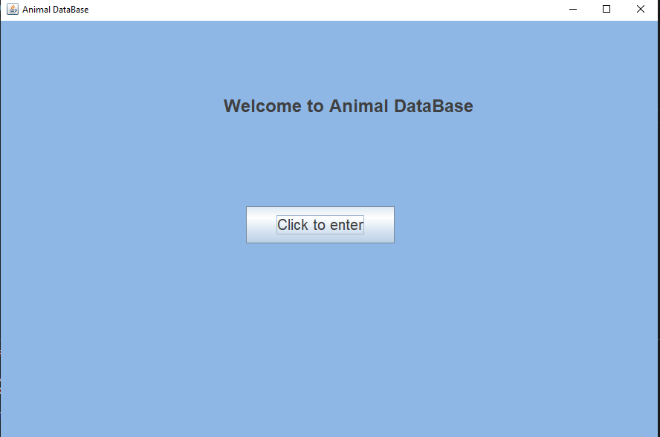

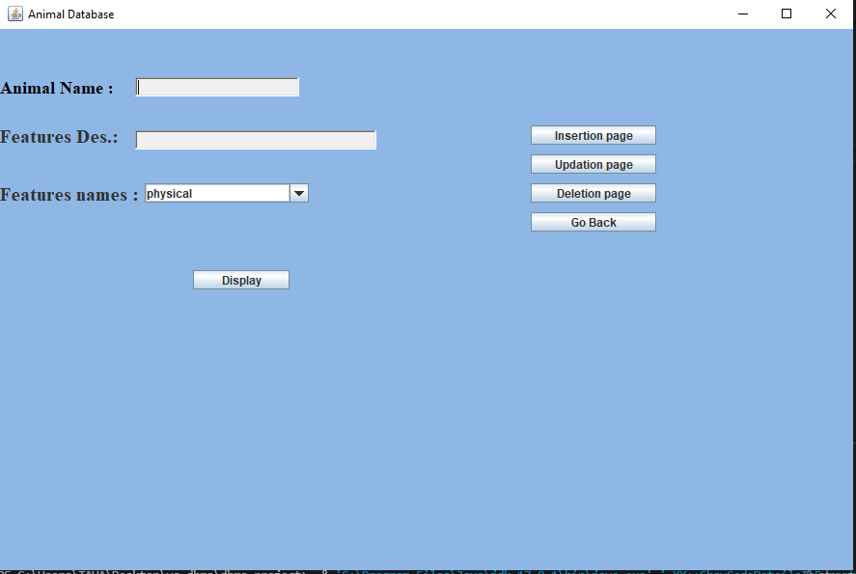

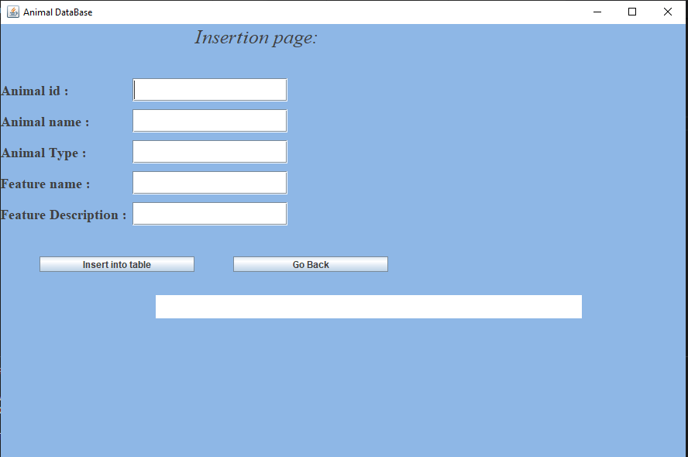

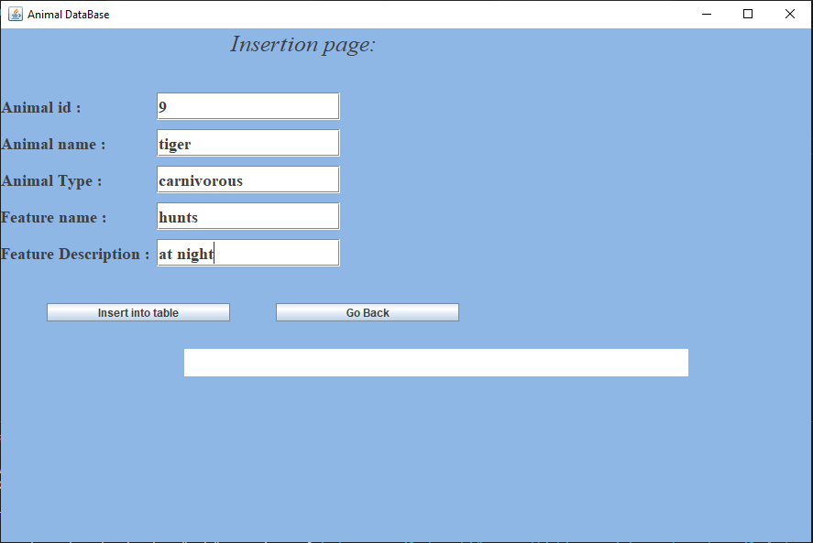

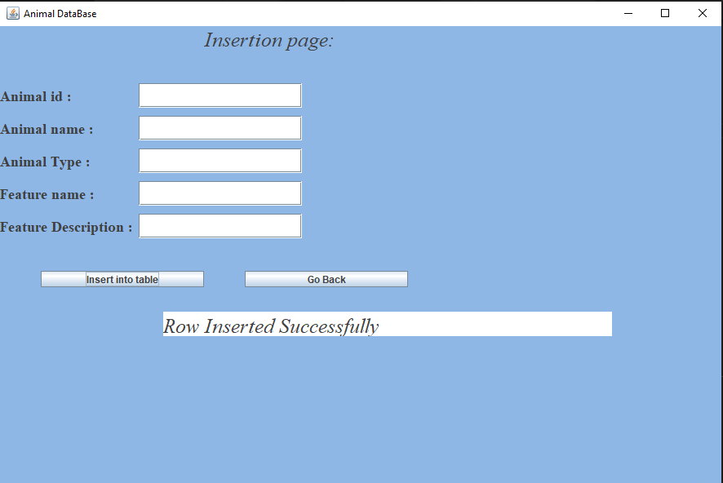

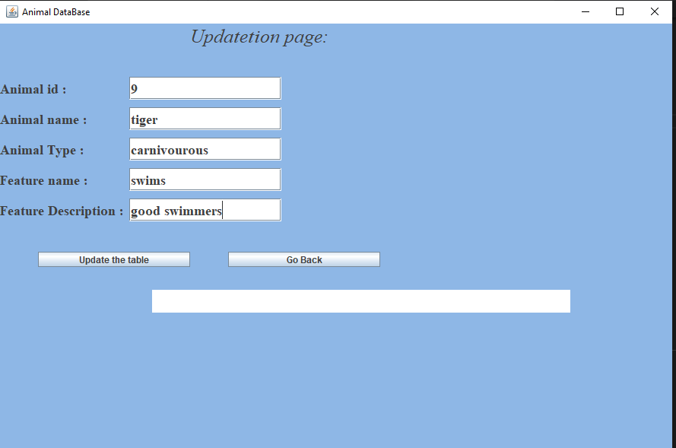

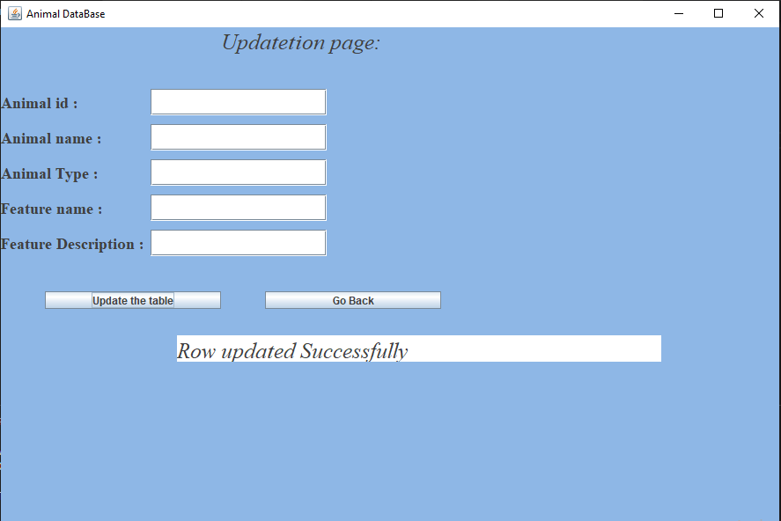

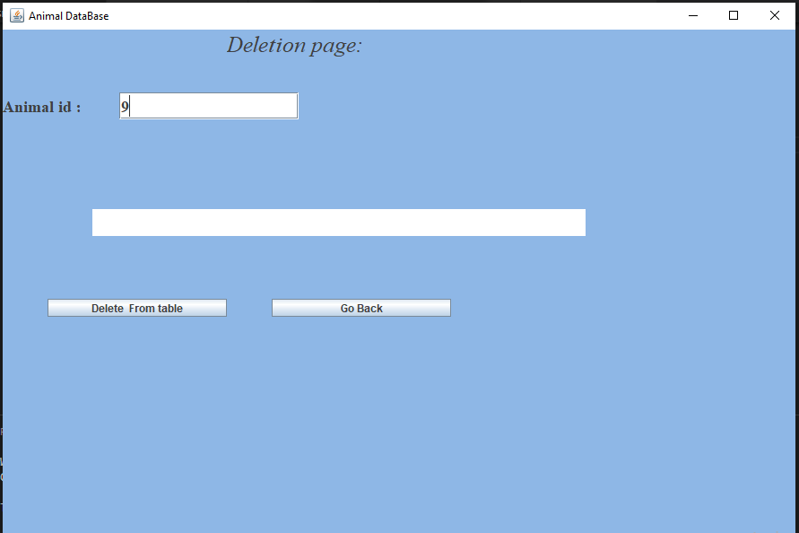

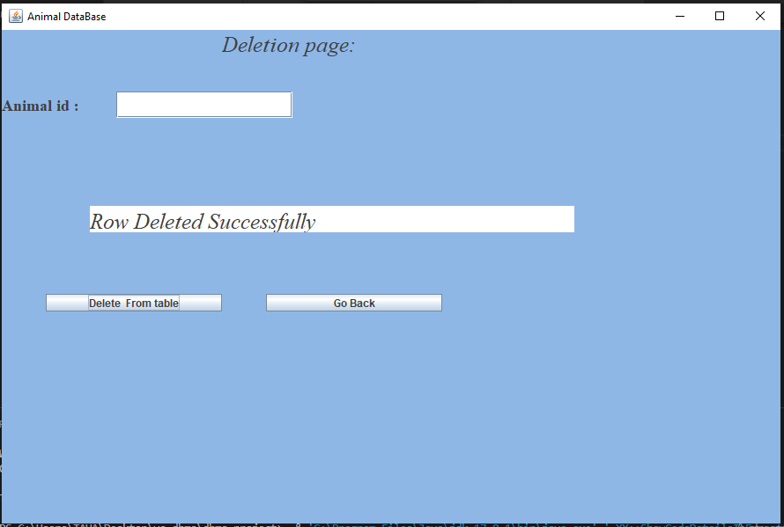

***FUTURE WORK :***

In the future we aim to add better search features using many other parameters and add other attributes in the projects table too.

**REFERENCES :**

<https://docs.oracle.com/javase/7/docs/api/>

<https://www.geeksforgeeks.org/establishing-jdbc-connection-in-java/>

<https://www.javatpoint.com/java-awt>